

We typically depart for Youngstown State University after classes Friday to arrive in time for registration, a system demonstration, and practice contest that evening. We then eat dinner, stay in a hotel, and arrive bright and early the next morning for the real competition. It lasts from 10am-3pm and consists of approx. 10 problems. Last year was exciting because we had 2 teams successfully solve 2 problems each! Problem solving skills and the ability to think critically offer just as much to a team as coding ability, so don’t let inexperience stop you from joining this great opportunity!

We typically depart for Youngstown State University after classes Friday to arrive in time for registration, a system demonstration, and practice contest that evening. We then eat dinner, stay in a hotel, and arrive bright and early the next morning for the real competition. It lasts from 10am-3pm and consists of approx. 10 problems. Last year was exciting because we had 2 teams successfully solve 2 problems each! Problem solving skills and the ability to think critically offer just as much to a team as coding ability, so don’t let inexperience stop you from joining this great opportunity!

“The International Collegiate Programming Contest is an algorithmic programming contest for college students. Teams of three, representing their university, work to solve the most real-world problems, fostering collaboration, creativity, innovation, and the ability to perform under pressure.”

- from icpc.baylor.edu

“The International Collegiate Programming Contest is an algorithmic programming contest for college students. Teams of three, representing their university, work to solve the most real-world problems, fostering collaboration, creativity, innovation, and the ability to perform under pressure.”

- from icpc.baylor.edu

We typically depart for Youngstown State University after classes Friday to arrive in time for registration, a system demonstration, and practice contest that evening. We then eat dinner, stay in a hotel, and arrive bright and early the next morning for the real competition. It lasts from 10am-3pm and consists of approx. 10 problems. Last year was exciting because we had 2 teams successfully solve 2 problems each! Problem solving skills and the ability to think critically offer just as much to a team as coding ability, so don’t let inexperience stop you from joining this great opportunity!

“The International Collegiate Programming Contest is an algorithmic programming contest for college students. Teams of three, representing their university, work to solve the most real-world problems, fostering collaboration, creativity, innovation, and the ability to perform under pressure.”

- from icpc.baylor.edu

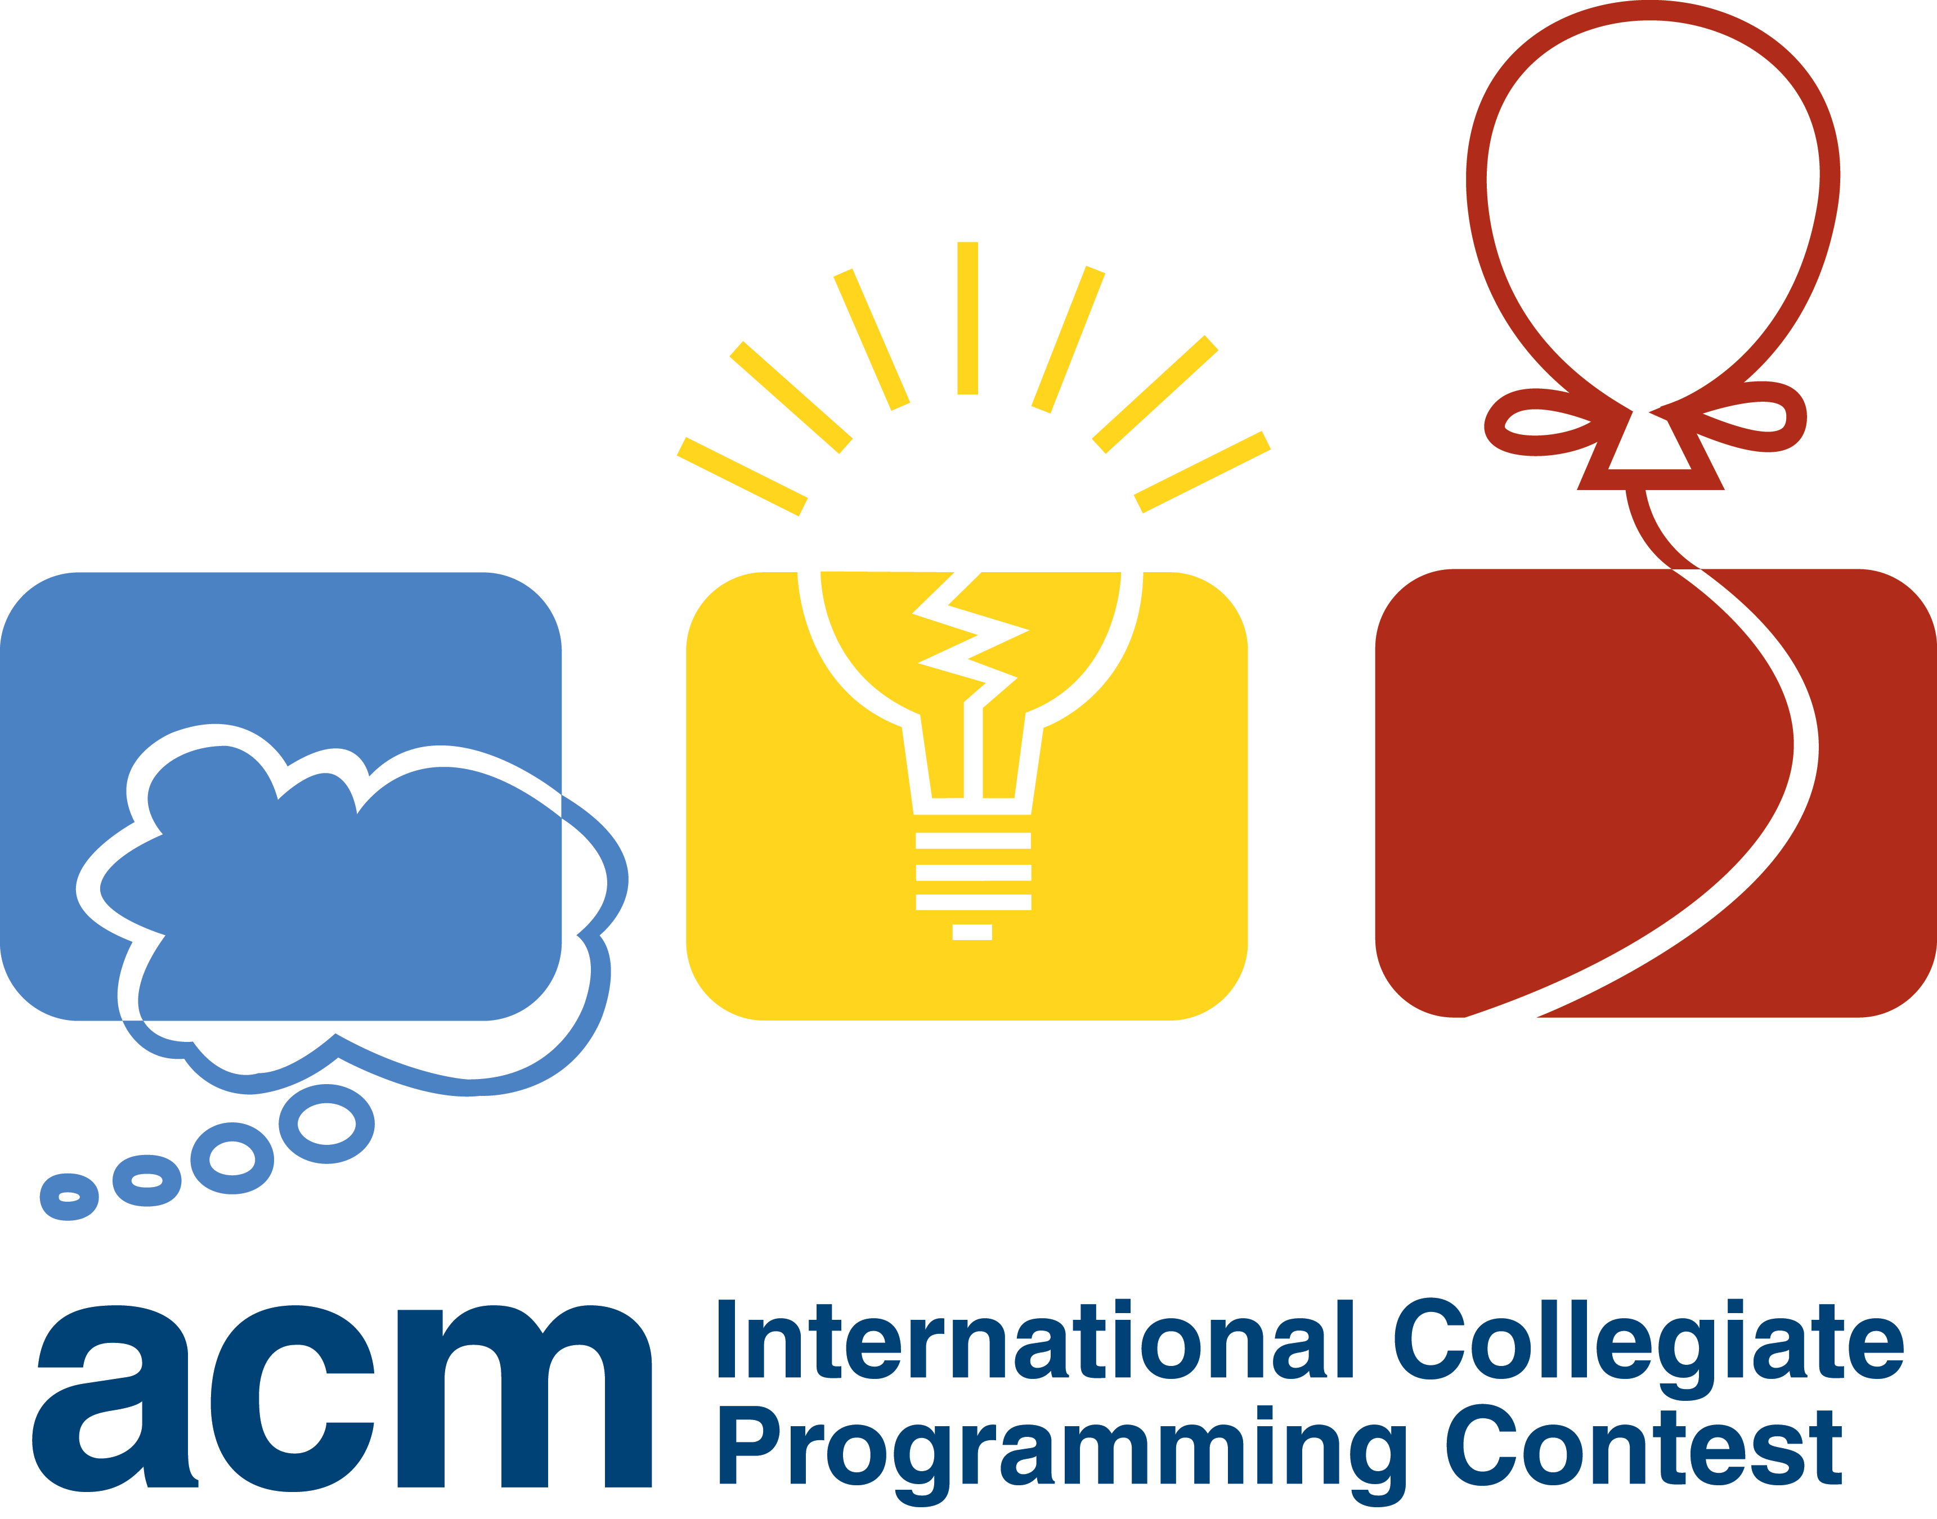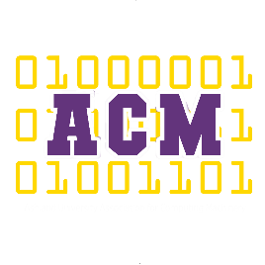

Interested? Contact someone below so we can get you registered! Our ACM club will also be hosting several meetings leading up to the competition with practice problems, general contest advice, and more

Dr. Ajwa (Faculty Advisor): iajwa@ashland.edu

Mohammed Bawazeer (ACM President): mbawazee@ashland.edu

Kelly Fullin (ACM Secretary): kfullin@ashland.edu

Competition Dates:

**Fri Nov 9 & Sat Nov 10**

Registration: Now – Oct 17

**Follow Ashland University ACM on**

Facebook: @AUACMClub

Twitter: @ACMAshland

**Follow Ashland University ACM on**

Facebook: @AUACMClub

Twitter: @ACMAshland

Competition Dates:

**Fri Nov 9 & Sat Nov 10**

Registration: Now – Oct 17

Interested? Contact someone below so we can get you registered! Our ACM club will also be hosting several meetings leading up to the competition with practice problems, general contest advice, and more

Dr. Ajwa (Faculty Advisor): iajwa@ashland.edu

Mohammed Bawazeer (ACM President): mbawazee@ashland.edu

Kelly Fullin (ACM Secretary): kfullin@ashland.edu

Competition Dates:

**Fri Nov 9 & Sat Nov 10**

Registration: Now – Oct 17

Interested? Contact someone below so we can get you registered! Our ACM club will also be hosting several meetings leading up to the competition with practice problems, general contest advice, and more

Dr. Ajwa (Faculty Advisor): iajwa@ashland.edu

Mohammed Bawazeer (ACM President): mbawazee@ashland.edu

Kelly Fullin (ACM Secretary): kfullin@ashland.edu

**Follow Ashland University ACM on**

Facebook: @AUACMClub

Twitter: @ACMAshland